

aUTOMATED iNFORMATION
COLLECTION SYSTEM

AICS

INSTALLATION GUIDE

Version 3.0

April 1997

Department of Veterans Affairs
Health Systems Design & Development (HSD&D)

Table of Contents

I. Introduction 1
Package Integration 1

II. Client 3
Pre-Install Steps 3
Installation Activity 3

III. Server 5
Pre-Install Steps 5
Installation Activity 5

IV. Appendix A - Files Installed on Client Workstation and Sample Installation

V. Appendix B - Sample Server Installation 23

VI. Appendix C - Checksum Values 35

VII. Appendix D - Scanner Calibration 39

I. Introduction

This package was created using Kernel V. 8.0 and VA FileMan V. 21.0. It was exported using the Kernel Installation and Distribution System (KIDS) instead of the FileMan DIFROM utility. You must use Kernel V. 8.0 to install this software. Installation (not including the placement of globals) will take between 2 and 15 minutes.

Please review the KIDS documentation and familiarize yourself with KIDS prior to installing this package.

Package Integration

The following package versions (or higher) must be installed prior to loading the AICS software. AICS's environment check routine checks for certain critical patches to each of these packages. Sites should verify that all patches to these packages have been installed prior to the install of AICS.

Kernel V. 8.0
VA FileMan V. 21.0
RPC Broker V. 1.0
PCE V. 1.0
PIMS V. 5.3
Kernel Toolkit V. 7.3
Clinical Lexicon Utility V. 1.0 or Lexicon Utility V. 2.0
Problem List V. 2.0 (including patch GMP*2*3)
Visit Tracking V. 2.0

During the Post Installation routine, AICS will determine the version of the Lexicon Utility you are running and will update the data dictionary for fields that point to the EXPRESSIONS file (#757.01) to the correct global location.

A list of the checksum values is located in Appendix C.

II. Client

Pre-Install Steps

You must have a client workstation that has the RPC Broker’s Client Manager running. You must be able to run the RPC Broker Test provided by the RPC Broker in order to run AICS. The client software needs to be installed on a workstation to do the scanning functionality for AICS. Workstations should conform to the “Veterans Health Administration Recommendations to the Field - August 3, 1995” document. This document may be found on the VHA Home Page - or directly via www.va.gov/wsnosrec.htm. The workstations must meet the following requirements.

1. At a minimum, be a 80486 CPU-based PC workstation with 20 megabytes of RAM. A Pentium 100 with 32 megabytes is the recommended minimum.

2. Have one of the following operating systems:
- MS Windows for Workgroups V. 3.11,
- MS Windows 95.

3. Have Network Capability:
- Each workstation should be networked into your VISTA Server through a local area network, using a network interface card and TCP/IP protocol; OR, under Windows 95, a Point-to-Point Protocol (PPP) into a Windows NT Server.
- Successfully run the RPC Broker’s RPC Broker Test on each client workstation. (See Section III - Server, Installation Activity.)

Installation Activity

Before you install AICS on a client workstation, you should have successfully run the RPC Broker Test program and executed each of its functions. You should also make sure that Paper Keyboard has been loaded. Do not proceed until this has been accomplished.

The following steps must be taken for each workstation that will be used as an AICS workstation.
1. Get AICS3_0.EXE.
This can be obtained from the appropriate anonymous software directory.
- Make sure to set transfer as BINARY.
- Get the AICS3_0.EXE file. Depending on the FTP software, this file should be placed in a shared directory. If you cannot find it, use Window's File Manager's Search functionality.

2. Find the AICS3_0.EXE file. It is not necessary to copy the file; the file can be run from the shared directory.

3. Run AICS3_0.EXE (double click on it). This starts the AICS installation. See Appendix A for information on the files installed on the Client Workstation and a sample run of the installation.
- Example: Run c:\xxx\AICS3_0.EXE from Program Manager.
- Take all the default prompts unless it causes a conflict.
- The install program creates an AICS directory, three subdirectories (unrforms, images, backup), and a new Windows Program Group. It populates the Program Group with the AICS Scanning Work Center Icon, the AICS Scanning Work Center Help Icon, and the AICS Scanning Work Center Uninstall Icon.

***Load Server software before continuing***

4. Run the AICS Client software.
- Double click on the AICS Scanning Work Center Icon.
- Logon either by clicking the logon speed button or by selecting Logon from the File Menu. Make entries for both access and verify codes. Note that moving the cursor over any button will display additional information on that button.
- Should an error dialog box appear with an ABORT or IGNORE button, clicking the ABORT will shut down the application; the IGNORE button will clear the exception and attempt to continue. If you IGNORE, you may see additional errors depending on the severity of the initial error.
- You have connected to the server database when you hear a bell and see the message displaying which server you are connected to at the bottom of the screen.
- Use the client software. Note that not all menu items are available and not all data fields have connections with the database.

5. Calibrate your scanner. Appendix D lists the steps to take in order to calibrate your scanner. This step must be done before scanning forms.
III. Server

Pre-Install Steps

You must have all current Kernel, Kernel Toolkit, VA FileMan, PCE, PIMS, Problem List, Visit Tracking, and RPC Broker patches installed.

Kernel V. 8.0
The following patches are checked for by the environment check routine.

XU*8*2
XU*8*15
XU*8*16
XU*8*28
XU*8*32
XU*8*44

Installation Activity

1. Install RPC Broker V. 1.0 using the RPC Broker Installation instructions.

Loading and Installing the KIDS Distribution should be accomplished during non-peak hours to minimize disruption to users. Installation of the KIDS Distribution will take less than 30 minutes.

a. Review your mapped set. If you map routines, you should disable routine mapping on the IBD* routines.

b. If you wish, you may disable journalling for IBE and IBD globals, as appropriate.

c. From the Kernel Installation and Distribution System Menu, select the Installation menu.

d. From this menu, select the Load a Distribution option. Enter “AICS3_0.KID” at the “Enter a Host File:” prompt. Enter YES at the “Want to Continue with Load? YES//” and “Want to RUN the Environment Check Routine? YES//” prompts.

e. From the Installation menu, you may elect to use the following options (when prompted for INSTALL NAME, enter AICS3_0.KID.).
- Backup a Transport Global - this option will create a backup message of any routines exported with the patch. It will NOT backup any other changes such as DDs or templates.
- Compare Transport Global to Current System - this option will allow you to view all changes that will be made upon installation. It compares all components of the package (routines, DDs, templates, etc.).
- Verify Checksums in Transport Global - this option will allow you to ensure the integrity of the routines that are in the transport global.

f. Use the Install Package(s) option and select the package, AICS3_0.KID.

g. Respond to the prompts as follows:

- Want to DISABLE Scheduled Options, Menu Options, and Protocols? YES// YES
- Disable IBD*

h. MSM sites: Please ensure you answer YES when asked if you want to move the routines to other systems, and indicate the appropriate CPUs.

i. If routines were unmapped as part of Step 1a, they should be returned to the mapped set once the installation has run to completion.

2. Assign Security Keys.

- IBDF IRM should be assigned to those who access the IRM menu option.
- IBD SCAN MANAGER should be assigned to the users who will be using the scanning software.
- IBD MANAGER should be assigned to the user who needs to perform functions in AICS that should not be allocated to all users of the package.

3. The IBD SCANNING WORKSTATION option must be given as a secondary menu to users who will be using the scanning software.

4. OPTIONAL: Print out a copy of the AICS builds.
- Select the Kernel Installation & Distribution System menu.
- Select the Utilities menu.
- Select Install File Print.
- Print Automated Info Collection Sys 3.0.
5. Verify that the following options are queued on the Taskmanager menu.

Option Name Frequency Device
==============================================================
IBDF AUTO PURGE FROM TRACKING 7D None
IBDF BACKGRD EF PRINT QUEUE 1D None

6. Enable Journaling on IBD and IBE globals.

7. Reload the routine map set and enable routine mapping. Routines recommended for mapping are: IBDF1*, IBDF2*, IBDF5A*, IBDF9A1*, IBDFQSC1, IBDFU*, IBDFDE*, IBDFBK*, and IBDFRPC*.

Note: It is necessary for all encounter forms to be recompiled due to a correction made to the narrative passed by scanning. The post init routine will uncompile all encounter forms. When printing forms, the forms will recompile in the background, invisible to the user.

Note: Two new parameters have been added to the ENCOUNTER FORM PARAMETERS file (# 357.09). The first, STOP DEFAULTING C/O DATE/TIME field #1.02, is an optional parameter to stop defaulting the check out date/time to the scanning date/time. The second is DAYS TO PRPINT 1010F. If choosing to print 1010F with the Encounter Forms, this is the number of days between expiration of a Means Test and the appointment date before that you want to print 1010Fs for.

8. A resource device, IBD Resource, is automatically added to your Device file with 1 resource slot allocated. Large sites may want to increase the number of resource slots.

9. Review the AICS V. 3.0 site parameters. Use the IBDF EDIT SITE PARAM option or run routine, ^IBDFESP. Enter the purge parameters. Initially, it is recommended that the RECORDS TO PURGE field be set to ALL to allow the purge utility to delete all appropriately aged records. The FORM TRACKING RETENTION DAYS field should be set to 60 to allow purging of all records at least 60 days old. After a site begins scanning the field, RECORDS TO PURGE should be set to COMPLETED to allow tracking of incomplete forms.
10. If you would like to receive notification when the purge completes, set up a public mail group whose recipients will receive a message for purging of records. This is not a bulletin per say, since there is not an entry in the Bulletin file. Also, that mail group must be entered in the IBDF EDIT SITE PARAM option for the parameter, PURGE NOTIFICATION MAIL GROUP. Make sure you are a member of this mail group. This mail group will automatically receive notification of purge results. Results are also stored in the AICS PURGE LOG file and may be reviewed. Mail notification is not required.

11. Edit the ENCOUNTER FORM PRINTERS file (#357.94) to indicate if a printer supports PCL5. In order to print a scannable form, this file must have an entry for the terminal type being used, and it must indicate that it is a PCL5-supported printer. Use the IBDF EDIT PRINTERS option or run routine, ^IBDFDVE. This option also adds the correct printer sequences for duplex printing to PCL5 printers (if you have not already done so).

12. With the release of AICS V. 3.0, the scanning software will default the checkout date/time to that of the time of scanning, if there is not a checkout date/time in PCE or no checkout date/time on the Encounter Form. Any site that wishes this not to happen (especially PANDAS sites), must enter YES at the "Stop Defaulting C/O Date/Time" prompt in the ENCOUNTER FORM PARAMETERS file (#357.09).

IV. Appendix A - Files Installed on Client Workstation and Sample Installation

C:\vista\aics\ibdscan.exe
C:\vista\aics\ibdscan.hlp
C:\vista\aics\ibdabt.dll
C:\vista\aics\unwise.exe
C:\paperkey\aicsmstr.fs
C:\paperkey\aicsscan.fs
C:\paperkey\ibdnorm.cfg
C:\paperkey\ibdrotd.cfg
C:\vista\aics\tutorials\Ibdcalib.exe
C:\vista\aics\tutorials\Ibddemo.exe
C:\vista\aics\tutorials\Ibddhcp.exe
C:\vista\aics\tutorials\Ibdpref.exe

The following series of screens are a representation of the screens the user will encounter when installing the AICS Scanning Workstation.
Initial Screen

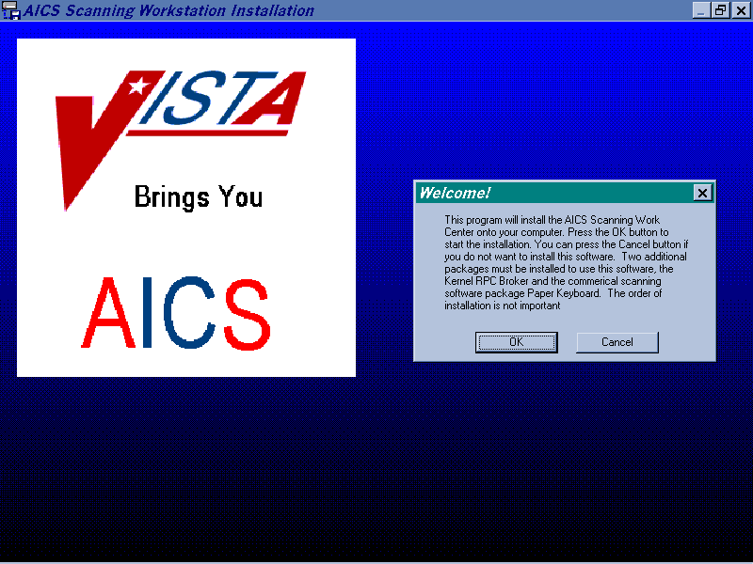

Answer OK to start the installation of the Workstation. If you choose to cancel, the installation will abort.
Destination Directory

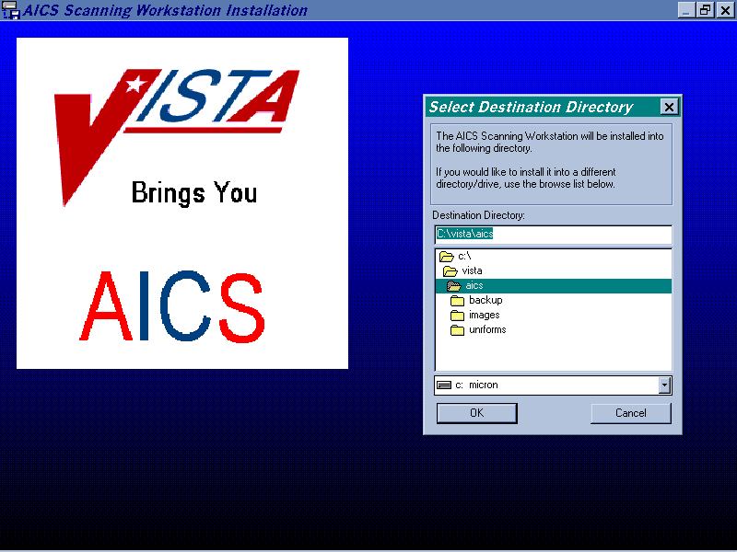

Choose the directory where the AICS Scanning Workstation will be installed. The default directory will be contained in the Destination Directory box. If you wish to install in another directory, choose your preference, then OK. If you choose to cancel, the installation will abort.
Backup Screen

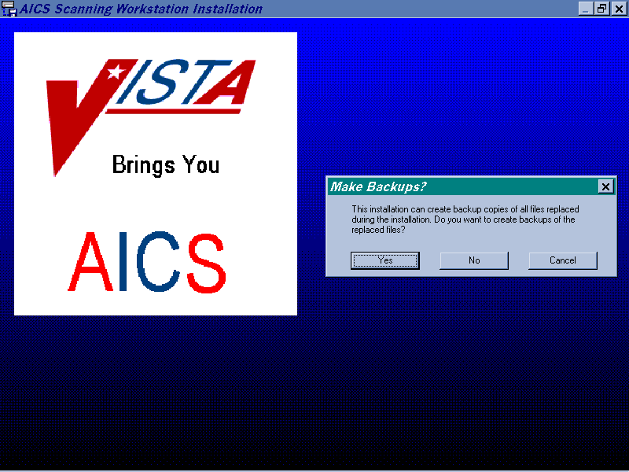

If the user wishes to make backup copies of the files that are modified during the installation, choose YES. If backup copies are not desired, answer NO. If you choose to cancel, the installation will abort.
Backup Directory

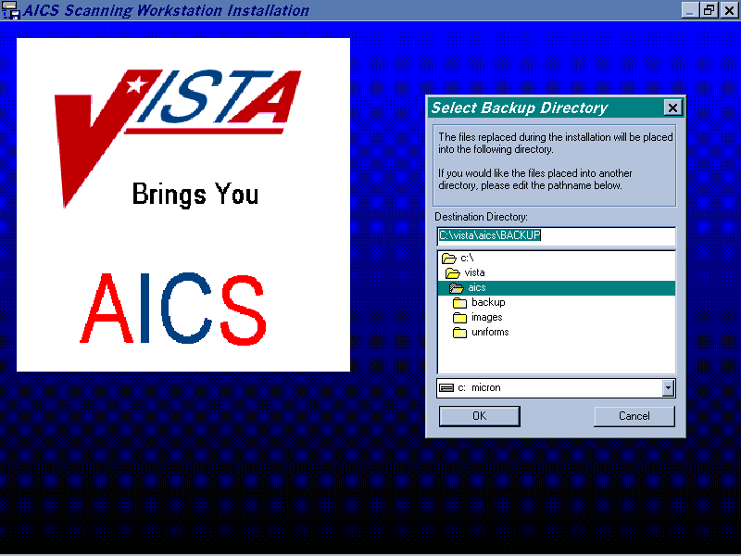

Select the directory that will store the files that will be backed up during installation. The default will be in the Destination Directory box, choose OK or choose the directory you wish to store the files in, then choose OK. If you choose to cancel, the installation will abort.
Paper Keyboard Directory

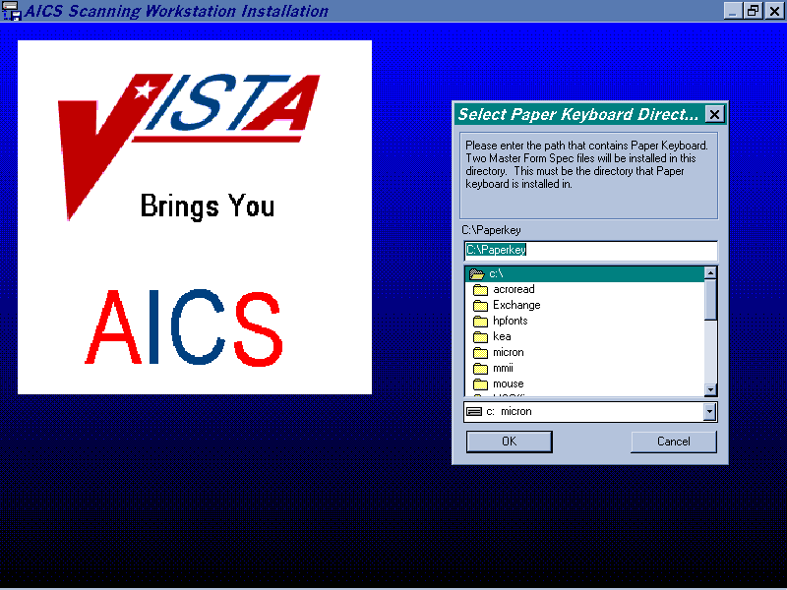

Select the path that contains Paper Keyboard. Two Master Form Spec files will be installed there. The default will be in the C:\Paperkey box. Choose OK or choose the directory you wish to install the Master Form Spec files in, then choose OK. If you choose to cancel, the installation will abort.
Delete Old Form Specs

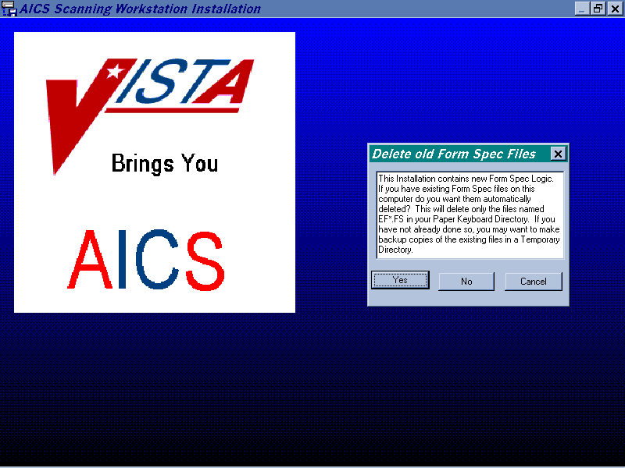

Answer YES to allow the automatic deletion of form specs in the Paper Keyboard directory with file names EF*.FS. Choosing NO will not allow this to occur. If you cancel, the program will abort. Remember to make backup copies of your files if you haven’t already done so.
Deleting Old Form Specs Confirmation

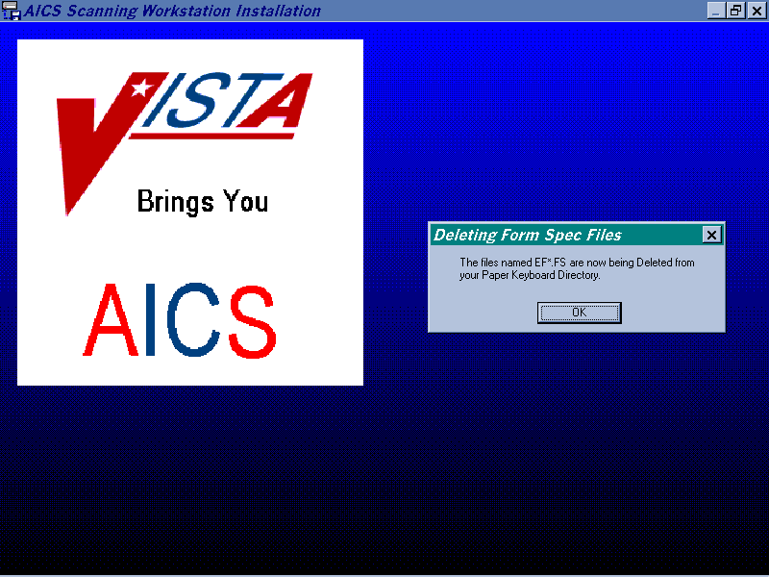

Answering OK will allow the form spec deletion to occur. Those files in the Paper Keyboard directory with file names EF*.FS will be deleted.
Select Scanner

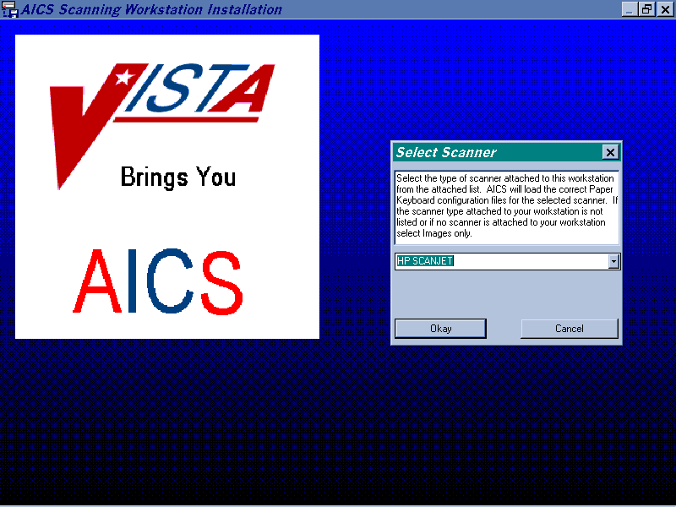

Select the type of scanner attached to this workstation from the pull down list. The correct Paper Keyboard configuration files will be loaded by AICS. Choose OK to select the scanner listed in the box. Choose cancel to abort the installation.
HP Scanner Selected

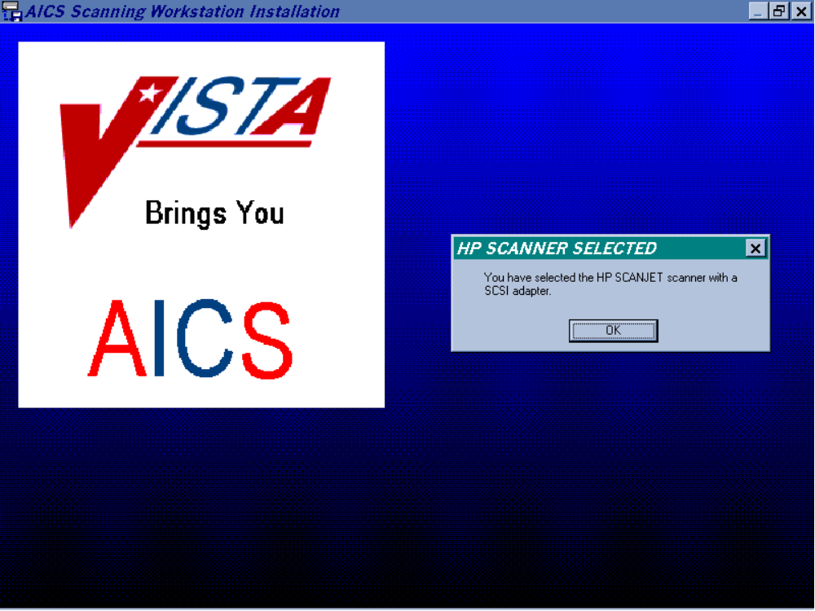

Choose OK to verify the scanner that you chose in the previous screen.
Install Tutorials

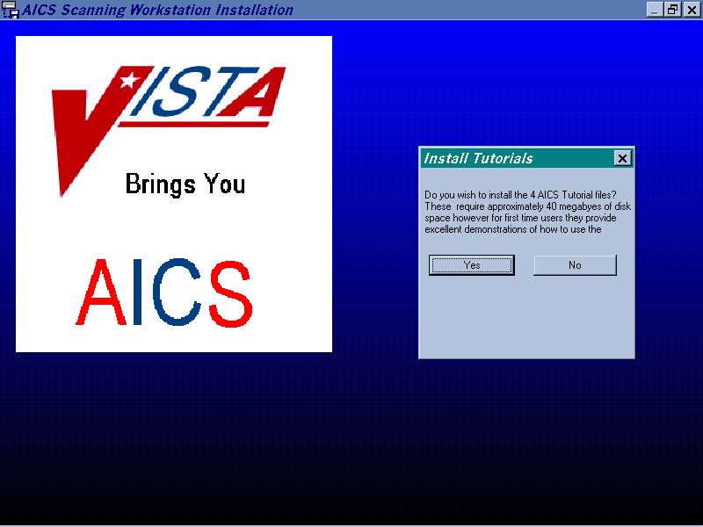

Choose YES to install the four tutorial files for the scanning software. Choosing NO will not install these files.
Workstation ID

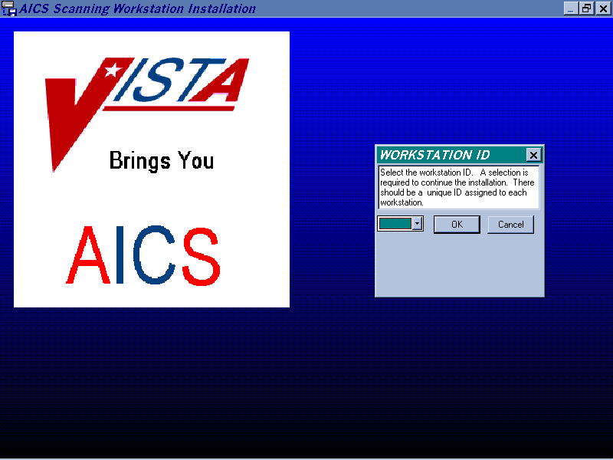

Choose the Workstation ID. The default ID from the installation script will be contained in the box. Each Workstation should have a unique ID. Choose one and select OK. If you choose to cancel, the installation will abort.
Setting DDE Time-out

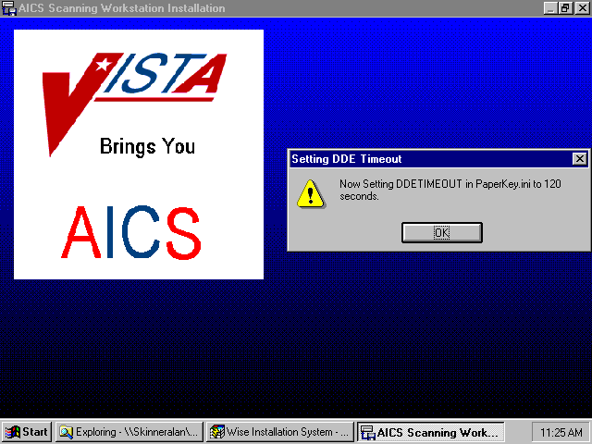

Answering OK to this prompt allows the DDE time-out to be set to 120 seconds. This screen will only display on the first installation.
Start Menu

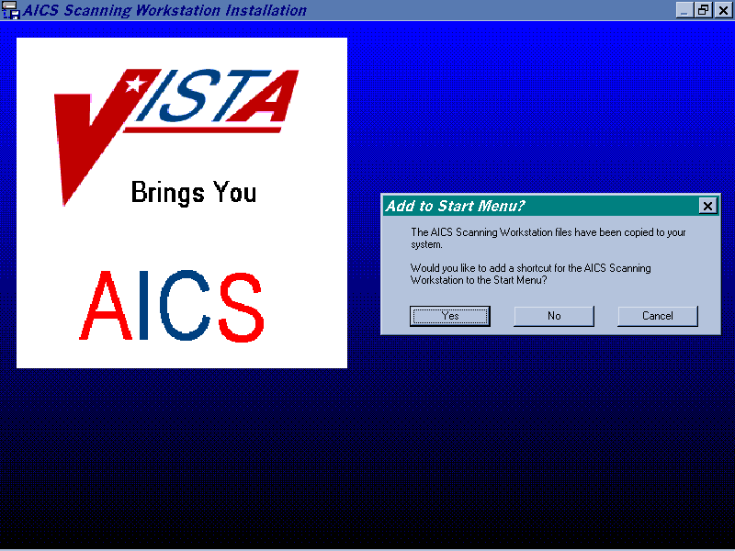

Choose Yes to add a shortcut for the AICS Scanning Workstation to the Start Menu. Choose No, to not do so. If you choose to cancel, the installation will abort.
V. Appendix B - Sample Server Installation

Sample FTP Download of AICS KIDS Distribution

ISC1A3$ FTP 152.127.1.5
220 ISC-ALBANY.VA.GOV FTP Server (Version V4.1-12) Ready.
Connected to 152.127.1.5.
Name (152.127.1.5:skinner): ANONYMOUS
331 Guest login ok, send ident as password.
Password:
230 Guest login ok, access restrictions apply.
FTP> cd software
250 CWD command successful.
FTP> get aics3*.kid
200 TYPE set to IMAGE.
200 PORT command successful.
150 Opening data connection for AICS3_0.KID;1 (152.127.1.8,4295)
226 Transfer complete.
local: VA3$:[SKINNER]AICS3_0.KID;1 remote: AICS3_0.KID;1
2164930 bytes received in 00:00:03.38 seconds (625.12 Kbytes/s)
FTP> binary
200 TYPE set to IMAGE.
FTP> get aics3*.exe
200 PORT command successful.
150 Opening data connection for AICS3_0.EXE;1 (152.127.1.8,4297)
226 Transfer complete.
local: VA3$:[SKINNER]AICS3_0.EXE;1 remote: AICS3_0.EXE;1
1454080 bytes received in 00:00:01.71 seconds (828.47 Kbytes/s)
FTP>bye
221 Goodbye

Sample KIDS Installation

>D ^XUP

Setting up programmer environment
Terminal Type set to: C-VT320

Select OPTION NAME: INSTALLATION XPD INSTALLATION MENU Installation

1 Load a Distribution
2 Verify Checksums in Transport Global
3 Print Transport Global
4 Compare Transport Global to Current System
5 Backup a Transport Global
6 Install Package(s)
Restart Install of Package(s)
Unload a Distribution
Select Installation Option: Load a Distribution
Enter a Host File: AICS3_0.KID

KIDS Distribution saved on Apr 24, 1997@11:24:33
Comment: AICS V3.0 RELEASE 4/24/97

This Distribution contains Transport Globals for the following Package(s):
AUTOMATED INFO COLLECTION SYS 3.0

Want to Continue with Load? YES// <RET>
Loading Distribution...

Want to RUN the Environment Check Routine? YES// <RET>
AUTOMATED INFO COLLECTION SYS 3.0
Will first run the Environment Check Routine, IBD3KENV

AICS 3.0 Installation Requirements:

>>> Checking Environment:
Environment checks OK

>>> Checking PACKAGE File Entries:
Checking for required patch XU*8.0*2...OK
Checking for required patch XU*8.0*15...OK
Checking for required patch XU*8.0*16...OK
Checking for required patch XU*8.0*28...OK
Checking for required patch XU*8.0*32...OK
Checking for required patch XU*8.0*44...OK
>>> Checking BUILD File Entries:
PCE V1.0 ...Ok - in Package File

>>> Environment is Ok
Use INSTALL NAME: AUTOMATED INFO COLLECTION SYS 3.0 to install this Distribution
.

1 Load a Distribution
2 Verify Checksums in Transport Global
3 Print Transport Global
4 Compare Transport Global to Current System
5 Backup a Transport Global
6 Install Package(s)
Restart Install of Package(s)
Unload a Distribution

Select Installation Option: VERify Checksums in Transport Global
Select INSTALL NAME: AUTOMATED INFO COLLECTION SYS 3.0 Loaded from Distribution 4/24/97@12:58:24
=> AICS V3.0 RELEASE 4/24/97 ;Created on Apr 24, 1997@11:24:33
DEVICE: HOME// <RET> LAT
PACKAGE: AUTOMATED INFO COLLECTION SYS 3.0 Apr 24, 1997 1:00 pm PAGE 1
------------------------------------------------------------------------------

213 Routine checked, 0 failed.

1 Load a Distribution
2 Verify Checksums in Transport Global
3 Print Transport Global
4 Compare Transport Global to Current System
5 Backup a Transport Global
6 Install Package(s)
Restart Install of Package(s)
Unload a Distribution

Select Installation Option: Backup a Transport Global
Select INSTALL NAME: AUTOMATED INFO COLLECTION SYS 3.0 Loaded from Distribution 4/24/97@12:58:24
=> AICS V3.0 RELEASE 4/24/97 ;Created on Apr 24, 1997@11:24:33

This Distribution was loaded on Apr 24, 1997@12:58:24 with header of
AICS V3.0 RELEASE 4/24/97 ;Created on Apr 24, 1997@11:24:33
It consisted of the following Install(s):
AUTOMATED INFO COLLECTION SYS 3.0

Subject: BACKUP AICS3_0 INSTALL
Loading Routines for AUTOMATED INFO COLLECTION SYS 3.0........
Routine IBD3KPT is not on the disk.................................
Routine IBDF18E0 is not on the disk...
Routine IBDF18E2 is not on the disk..
Routine IBDF18E3 is not on the disk.............................................
...........
Routine IBDFBKS is not on the disk..
Routine IBDFBKS1 is not on the disk..
Routine IBDFBKS2 is not on the disk..
Routine IBDFBKS3 is not on the disk..
Routine IBDFBKS4 is not on the disk...........
Routine IBDFCMP is not on the disk..
Routine IBDFCMP1 is not on the disk......
Routine IBDFDE10 is not on the disk.......
Routine IBDFDE41 is not on the disk..
Routine IBDFDE42 is not on the disk...........
Routine IBDFFRFT is not on the disk......
Routine IBDFFT3 is not on the disk..
Routine IBDFFT4 is not on the disk..............
Routine IBDFN11 is not on the disk..................
Routine IBDFOSG9 is not on the disk.......................
Routine IBDFST1 is not on the disk..................................
Send mail to:Yourself,You Last used MailMan: 13 Jun 96 08:56
Select basket to send to: IN// <RET>
And send to: <RET>

1 Load a Distribution
2 Verify Checksums in Transport Global
3 Print Transport Global
4 Compare Transport Global to Current System
5 Backup a Transport Global
6 Install Package(s)
Restart Install of Package(s)
Unload a Distribution

Select Installation Option: INStall Package(s)
Select INSTALL NAME: AUTOMATED INFO COLLECTION SYS 3.0
Loaded from Distribution 4/24/97@12:58:24
=> AICS V3.0 RELEASE 4/24/97 ;Created on Apr 24, 1997@11:24:33

This Distribution was loaded on Apr 24, 1997@12:58:24 with header of
AICS V3.0 RELEASE 4/24/97 ;Created on Apr 24, 1997@11:24:33
It consisted of the following Install(s):
AUTOMATED INFO COLLECTION SYS 3.0

AUTOMATED INFO COLLECTION SYS 3.0
Will first run the Environment Check Routine, IBD3KENV

AICS 3.0 Installation Requirements:

>>> Checking Environment:
Environment checks OK

>>> Checking PACKAGE File Entries:
Checking for required patch XU*8.0*2...OK
Checking for required patch XU*8.0*15...OK
Checking for required patch XU*8.0*16...OK
Checking for required patch XU*8.0*28...OK
Checking for required patch XU*8.0*32...OK
Checking for required patch XU*8.0*44...OK
>>> Checking BUILD File Entries:
PCE V1.0 ...Ok - in Package File

>>> Environment is Ok

Install Questions for AUTOMATED INFO COLLECTION SYS 3.0

Incoming Files:

357 ENCOUNTER FORM
Note: You already have the 'ENCOUNTER FORM' File.
357.08 AICS PURGE LOG
Note: You already have the 'AICS PURGE LOG' File.

357.09 ENCOUNTER FORM PARAMETERS
Note: You already have the 'ENCOUNTER FORM PARAMETERS' File.

357.1 ENCOUNTER FORM BLOCK
Note: You already have the 'ENCOUNTER FORM BLOCK' File.

357.2 SELECTION LIST
Note: You already have the 'SELECTION LIST' File.

357.3 SELECTION
Note: You already have the 'SELECTION' File.

357.4 SELECTION GROUP
Note: You already have the 'SELECTION GROUP' File.

357.5 DATA FIELD
Note: You already have the 'DATA FIELD' File.

357.6 PACKAGE INTERFACE (including data)
Note: You already have the 'PACKAGE INTERFACE' File.
I will OVERWRITE your data with mine.

357.69 TYPE OF VISIT (including data)
Note: You already have the 'TYPE OF VISIT' File.
I will MERGE your data with mine.

357.7 FORM LINE
Note: You already have the 'FORM LINE' File.

357.8 TEXT AREA
Note: You already have the 'TEXT AREA' File.

357.91 MARKING AREA TYPE (including data)
Note: You already have the 'MARKING AREA TYPE' File.
I will OVERWRITE your data with mine.

357.92 PRINT CONDITIONS (including data)
Note: You already have the 'PRINT CONDITIONS' File.
I will OVERWRITE your data with mine.
357.93 MULTIPLE CHOICE FIELD
Note: You already have the 'MULTIPLE CHOICE FIELD' File.

357.94 ENCOUNTER FORM PRINTERS
Note: You already have the 'ENCOUNTER FORM PRINTERS' File.

357.95 FORM DEFINITION
Note: You already have the 'FORM DEFINITION' File.

357.96 ENCOUNTER FORM TRACKING
Note: You already have the 'ENCOUNTER FORM TRACKING' File.

357.97 ENCOUNTER FORM COUNTERS
*BUT YOU ALREADY HAVE 'ENCOUNTER FORM COUNTER FILE' AS FILE #357.97!
Shall I write over your ENCOUNTER FORM COUNTER FILE File? YES// Y

357.98 AICS DATA QUALIFIERS (including data)
*BUT YOU ALREADY HAVE 'ENCOUNTER FORM DATA QUALIFIERS' AS FILE #357.98!
Shall I write over your ENCOUNTER FORM DATA QUALIFIERS File? YES// Y
I will MERGE your data with mine.

357.99 PRINT MANAGER CLINIC GROUPS
Note: You already have the 'PRINT MANAGER CLINIC GROUPS' File.

358 IMP/EXP ENCOUNTER FORM (including data)
Note: You already have the 'IMP/EXP ENCOUNTER FORM' File.
I will OVERWRITE your data with mine.

358.1 IMP/EXP ENCOUNTER FORM BLOCK (including data)
Note: You already have the 'IMP/EXP ENCOUNTER FORM BLOCK' File.
I will OVERWRITE your data with mine.

358.2 IMP/EXP SELECTION LIST (including data)
Note: You already have the 'IMP/EXP SELECTION LIST' File.
I will OVERWRITE your data with mine.

358.3 IMP/EXP SELECTION (including data)
Note: You already have the 'IMP/EXP SELECTION' File.
I will OVERWRITE your data with mine.

358.4 IMP/EXP SELECTION GROUP (including data)
Note: You already have the 'IMP/EXP SELECTION GROUP' File.
I will OVERWRITE your data with mine.
358.5 IMP/EXP DATA FIELD (including data)
Note: You already have the 'IMP/EXP DATA FIELD' File.
I will OVERWRITE your data with mine.

358.6 IMP/EXP PACKAGE INTERFACE (including data)
Note: You already have the 'IMP/EXP PACKAGE INTERFACE' File.
I will OVERWRITE your data with mine.

358.7 IMP/EXP FORM LINE (including data)
Note: You already have the 'IMP/EXP FORM LINE' File.
I will OVERWRITE your data with mine.

358.8 IMP/EXP TEXT AREA (including data)
Note: You already have the 'IMP/EXP TEXT AREA' File.

358.91 IMP/EXP MARKING AREA (including data)
Note: You already have the 'IMP/EXP MARKING AREA' File.
I will OVERWRITE your data with mine.

358.93 IMP/EXP MULTIPLE CHOICE FIELD (including data)
Note: You already have the 'IMP/EXP MULTIPLE CHOICE FIELD' File.
I will OVERWRITE your data with mine.

358.94 IMP/EXP HAND PRINT FIELD (including data)
Note: You already have the 'IMP/EXP HAND PRINT FIELD' File.
I will OVERWRITE your data with mine.

358.98 IMP/EXP AICS DATA QUALIFIERS (including data)
Note: You already have the 'IMP/EXP AICS DATA QUALIFIERS' File.
I will OVERWRITE your data with mine.

358.99 IMP/EXP AICS DATA ELEMENTS (including data)
Note: You already have the 'IMP/EXP AICS DATA ELEMENTS' File.
I will OVERWRITE your data with mine.

359 CONVERTED FORMS
Note: You already have the 'CONVERTED FORMS' File.

359.1 AICS DATA ELEMENTS (including data)
Note: You already have the 'AICS DATA ELEMENTS' File.
I will OVERWRITE your data with mine.
359.2 FORM SPECS
Note: You already have the 'FORM SPECS' File.

359.3 AICS ERROR AND WARNING LOG

359.94 HAND PRINT FIELD
Note: You already have the 'HAND PRINT FIELD' File.

409.95 PRINT MANAGER CLINIC SETUP
Note: You already have the 'PRINT MANAGER CLINIC SETUP' File.

409.96 PRINT MANAGER DIVISION SETUP
Note: You already have the 'PRINT MANAGER DIVISION SETUP' File.

Want to DISABLE Scheduled Options, Menu Options, and Protocols? YES// <RET>

Enter options you wish to mark as 'Out Of Order': IBD*

Enter options you wish to mark as 'Out Of Order': <RET>

Enter protocols you wish to mark as 'Out Of Order': IBD*

Enter protocols you wish to mark as 'Out Of Order': <RET>

Delay Install (Minutes): (0-60): 0// <RET>

Enter the Device you want to print the Install messages.
You can queue the install by enter a 'Q' at the device prompt.
Enter a '^' to abort the install.

DEVICE: HOME// <RET> LAT

Install Started for AUTOMATED INFO COLLECTION SYS 3.0 :
Apr 24, 1997@13:05:39

Installing Routines:
Apr 24, 1997@13:06:46

Running Pre-Install Routine: ^IBDE2

Installing Data Dictionaries:
Apr 24, 1997@13:07:59

Installing Data:
Apr 24, 1997@13:08:18
Installing PACKAGE COMPONENTS:

Installing SECURITY KEY

Installing PRINT TEMPLATE

Installing SORT TEMPLATE

Installing INPUT TEMPLATE

Installing DIALOG

Installing PROTOCOL

Installing REMOTE PROCEDURE

Installing LIST TEMPLATE

Installing OPTION
Apr 24, 1997@13:09:25

Running Post-Install Routine: ^IBD3KPT
>>> Now Attempting to automatically update Tool Kit forms and Tool Kit Blocks.

Moving Block 'EYE ART I V3.0' from import/export to Tool Kit
Moving Block 'EYE ART II V3.0' from import/export to Tool Kit
Moving Block 'HIDDEN CLASSIFICATIONS (V3.0)' from import/export to Tool Kit

Moving Block 'PATIENT IMMUNIZATIONS (V3.0)' from import/export to Tool Kit

Moving Block 'PRACTITIONER(V3.0)' from import/export to Tool Kit
>>> Tool Kit Forms sent (4): 0 installed
>>> Tool Kit Blocks sent (28): 5 installed
>>> AICS Data Dictionaries updated to use Clinical Lexicon Utility version 1.0

>>> Form Specs being deleted and recreated for scanning.
>>> Deleting Fields *'d for Deletion in Package Interface file (357.6)

Updating Routine file...

The following Routines were created during this install:
IBDX0
IBDX01
IBDX02
IBDX03
IBDX04
IBDX1
IBDX11
IBDX110
IBDX12
IBDX13
IBDX14
IBDX15
IBDX16
IBDX17
IBDX18
IBDX19
IBDX2
IBDX21
IBDX22
IBDX23
IBDX24
IBDX25
IBDX26
IBDX3
IBDX31
IBDX32
IBDX33
IBDX34
IBDX4
IBDX41
IBDX42
IBDX5
IBDX51
IBDX52
IBDX53
IBDX54
IBDX95
IBDX951
IBDX9510
IBDX9511
IBDX9512
IBDX952
IBDX953
IBDX954
IBDX955
IBDX956
IBDX957
IBDX958
IBDX959
IBDXI5
IBDXI51
IBDXI52
IBDXI53
IBDXI2
IBDXI21
IBDXI22
IBDXI23
IBDXI24
IBDXI25
IBDXI26
IBDXI93
IBDXI931
IBDXI932
IBDXI933
IBDX96
IBDX961
IBDX97

Updating KIDS files...

AUTOMATED INFO COLLECTION SYS 3.0 Installed.
Apr 24, 1997@13:09:57

Install Message sent #61805
------------------------------------------------------------------------------
+------------------------------------------------------------------+
100% | 25 50 75 |
Complete +------------------------------------------------------------------+

Install Completed

Load a Distribution
Verify Checksums in Transport Global
Print Transport Global
Compare Transport Global to Current System
Backup a Transport Global
Install Package(s)
Restart Install of Package(s)
Unload a Distribution

Select Installation Option: <RET>

Do you really want to halt? YES// <RET>

VI. Appendix C - Checksum Values

The following are CHECK^XTSUMBLD Checksum values for AICS V. 3.0.

IBD3KENV value = 2482893
IBD3KPT value = 11964813
IBD3KPT1 value = 561736
IBDF10 value = 11871257
IBDF10A value = 14844945
IBDF10B value = 4334206
IBDF10C value = 7145394
IBDF11 value = 3746255
IBDF11A value = 3372216
IBDF12 value = 2449474
IBDF13 value = 6065810
IBDF14 value = 2806524
IBDF14A value = 8128142
IBDF15 value = 2835740
IBDF15A value = 9106437
IBDF16 value = 8212382
IBDF17 value = 7062222
IBDF18 value = 5760005
IBDF18A value = 3427205
IBDF18A1 value = 8968373
IBDF18B value = 1183119
IBDF18C value = 9383133
IBDF18D value = 2224052
IBDF18E value = 11340277
IBDF18E0 value = 11693827
IBDF18E1 value = 10375249
IBDF18E2 value = 4914156
IBDF18E3 value = 554180
IBDF19 value = 7787654
IBDF1A value = 6906704
IBDF1B value = 13886733
IBDF1B1 value = 11709608
IBDF1B1A value = 12963462
IBDF1B1B value = 1767481
IBDF1B2 value = 2289984
IBDF1B3 value = 7853311
IBDF1B5 value = 11098411
IBDF1BA value = 11321310
IBDF1C value = 4183587
IBDF2A value = 13089889
IBDF2A1 value = 16675892
IBDF2A2 value = 5398601
IBDF2B value = 7733441
IBDF2B1 value = 2426473
IBDF2D value = 11307498
IBDF2D1 value = 7091947
IBDF2D2 value = 20452649
IBDF2D3 value = 12284133
IBDF2E value = 1625292
IBDF2F value = 14953767
IBDF2F1 value = 6492541
IBDF2G value = 1305076
IBDF2H value = 1131607
IBDF3 value = 7478886
IBDF4 value = 18681956
IBDF4A value = 13810939
IBDF5 value = 9209729
IBDF5A value = 4140889
IBDF5B value = 6698423
IBDF5C value = 3822764
IBDF5D value = 5086357
IBDF6 value = 8604587
IBDF6A value = 6144443
IBDF6C value = 1009133
IBDF7 value = 2565275
IBDF8 value = 1630744
IBDF9 value = 3819084
IBDF9A value = 16913688
IBDF9A1 value = 7479813
IBDF9A3 value = 7052911
IBDF9B value = 11180213
IBDF9B1 value = 13740809
IBDF9B2 value = 6322343
IBDF9B3 value = 5177091
IBDF9B4 value = 6134853
IBDF9C value = 5406188
IBDF9D value = 5163363
IBDF9E value = 5934543
IBDFBK1 value = 4906853
IBDFBK2 value = 6362708
IBDFBK3 value = 16698204
IBDFBKR value = 7402561
IBDFBKS value = 15247370
IBDFBKS1 value = 5830972
IBDFBKS2 value = 14974345
IBDFBKS3 value = 12904114
IBDFBKS4 value = 8554663
IBDFC value = 11407114
IBDFC1 value = 4784941
IBDFC2 value = 8753867
IBDFC2A value = 8223304
IBDFC2B value = 13124658
IBDFC3 value = 3078465
IBDFC4 value = 60053
IBDFCG value = 16657494
IBDFCG1 value = 6651180
IBDFCMP value = 10284232
IBDFCMP1 value = 12808450
IBDFCNOF value = 9651795
IBDFDE value = 28292527
IBDFDE0 value = 11338817
IBDFDE1 value = 13698331
IBDFDE10 value = 424026
IBDFDE2 value = 20881171
IBDFDE21 value = 20139881
IBDFDE22 value = 5338516
IBDFDE3 value = 18089819
IBDFDE4 value = 11204271
IBDFDE41 value = 6974404
IBDFDE42 value = 2472593
IBDFDE5 value = 20092356
IBDFDE6 value = 20813168
IBDFDE61 value = 2306021
IBDFDE7 value = 13809118
IBDFDE8 value = 7762272
IBDFDE9 value = 7383712
IBDFDEA value = 11764220
IBDFDVE value = 392266
IBDFESP value = 5681865
IBDFFRFT value = 5605728
IBDFFSMP value = 4992963
IBDFFT value = 19343496
IBDFFT1 value = 38001031
IBDFFT2 value = 3352777
IBDFFT3 value = 19870534
IBDFFT4 value = 4158691
IBDFFV value = 7432713
IBDFFV1 value = 2385105
IBDFFV2 value = 4347225
IBDFFV3 value = 5257927
IBDFGRP value = 9136849
IBDFHLP value = 3402730
IBDFLST value = 11634433
IBDFLST1 value = 1683695
IBDFM1 value = 13441067
IBDFN value = 15680196
IBDFN1 value = 1213860
IBDFN10 value = 2765146
IBDFN11 value = 2856878
IBDFN12 value = 1612905
IBDFN13 value = 66244
IBDFN14 value = 2226507
IBDFN2 value = 8020032
IBDFN3 value = 2845147
IBDFN4 value = 2973307
IBDFN5 value = 3054776
IBDFN6 value = 2853724
IBDFN7 value = 1460739
IBDFN8 value = 124808
IBDFN9 value = 194363
IBDFOSG value = 10173582
IBDFOSG1 value = 7086168
IBDFOSG2 value = 13313314
IBDFOSG3 value = 7158757
IBDFOSG4 value = 3710643
IBDFPCE value = 2696567
IBDFPE value = 12450329
IBDFPE1 value = 8310152
IBDFPRG value = 7553882
IBDFPRG1 value = 2560350
IBDFQB value = 12597674
IBDFQEA value = 11843748
IBDFQEA1 value = 44681
IBDFQS value = 1334094
IBDFQSL value = 3215307
IBDFQSL1 value = 7683177
IBDFQSL2 value = 5616996
IBDFREG value = 5649578
IBDFRPC value = 8402302
IBDFRPC1 value = 3939573
IBDFRPC2 value = 13348413
IBDFRPC3 value = 5251659
IBDFRPC4 value = 5575808
IBDFSS value = 16958149
IBDFSS1 value = 2595117
IBDFST value = 11142778
IBDFST1 value = 11299943
IBDFU value = 15610352
IBDFU1 value = 12896586
IBDFU10 value = 522009
IBDFU1A value = 1409234
IBDFU1B value = 5339731
IBDFU1C value = 6702058
IBDFU2 value = 11675915
IBDFU2A value = 14139503
IBDFU2B value = 14408614
IBDFU2C value = 9269483
IBDFU3 value = 5569853
IBDFU4 value = 3631011
IBDFU5 value = 8489458
IBDFU5A value = 3373891
IBDFU6 value = 331661
IBDFU7 value = 665770
IBDFU8 value = 6550892
IBDFU9 value = 2718995
IBDFU91 value = 1874757
IBDFUA value = 3285590
IBDFUTI value = 3380251
IBDFUTL value = 11719221
IBDFUTL1 value = 21879277
IBDFUTL2 value = 11033351
IBDFUTL3 value = 3224598
IBDNTEG value = 4174439
IBDNTEG0 value = 3274825
IBDNTEG1 value = 2444
IBDNTEG2 value = 2452
IBDPPRE value = 2504995
IBDPPT value = 292463
IBDY217 value = 1013587
VII. Appendix D - Scanner Calibration

Paper Keyboard is the proprietary software that was chosen to interface the AICS workstation with a scanner. Many different types of scanners may be used, and as a result of the differences between them, it may be necessary to calibrate your scanner with Paper Keyboard. Calibration should only be necessary under the following circumstances.

- Initial scanner hook-up on a workstation.
- Scanner is replaced at a workstation.
- Sheet feed mechanism is added or removed from the scanner.
- Paper Keyboard continually cannot recognize anchors on your form, forcing you to manually locate them.

In order to calibrate Paper Keyboard with your scanner, it is necessary to understand the components on a form that make it scannable. They are:

- Anchor Marks: used to align the form,
- Scannable Page Block: used to determine if the page is scannable,
- Form, ID and Page Numbers: used to recognize the form being read.

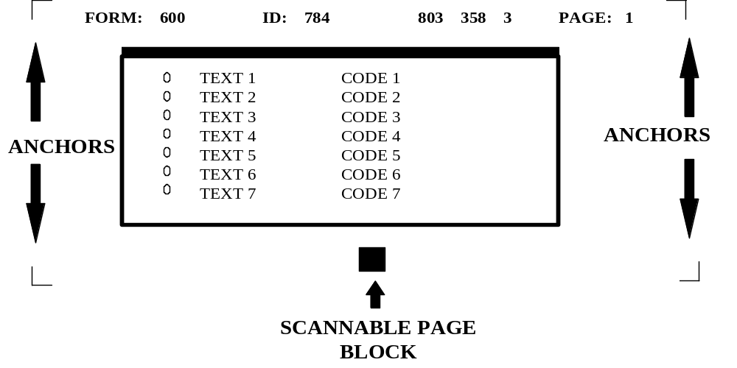During scanning, a Form Specification file is loaded that tells Paper Keyboard where to look for the anchors and scannable page block on a form. Paper Keyboard will attempt to locate these items in order to align the form before recognizing the data on the form. Sometimes, due to variations in scanners and/or shrinkage of forms, Paper Keyboard will not be able to locate these items. Calibrating Paper Keyboard with your scanner upon initial setup should prevent this from occurring. To calibrate the scanner, you should follow these steps:

- Select a form to calibrate from.
- Use a form that has actual printed patient data.
- Do not use a form that does not have a FORM or ID number located on the top of the form.
- If you are using a Bell & Howell scanner on this workstation, AND you will be using the duplex feature (reading both sides at once), select a form that has been printed duplex with a short-edge binding (form is printed head to toe on both sides of the paper.)
- You do NOT need to calibrate for each different form you have. You are simply selecting a form to use as a guide.

- Start up the AICS software.

- Highlight the key located in the upper left-hand corner of the AICS window. This will result in a sign-on to VISTA. It is necessary to be signed-on to VISTA to calibrate your forms, since any file specifications not already resident on the workstation will automatically be retrieved from VISTA during the calibration process.

- Select the Options menu from the menu bar located at the top of the screen.

- From the Options menu, select Preferences.

- From the Preferences screen, select the Advanced button located at the lower right hand corner of the window.

- You are now in the AICS Advanced Preferences window. You MUST calibrate your scanner twice. The first time through, you will calibrate for a normal page orientation, and the second time through you will calibrate for a rotated page orientation. This will allow Paper Keyboard to read your form whether it is fed in right-side-up or up-side-down. Select the page orientation you wish to calibrate for by pressing the appropriate button:
- Calibrate Normal Scanner Settings, or
- Calibrate Rotated Scanner Settings.
- You are now prompted to be sure the paper is in the scanner. To determine which way your paper should be facing, see the following chart.

 | Normal Calibration | Rotated  Calibration
Hewlett Packard | Front side of EF facing up and positioned upright in the scanner | Back side of EF facing up and positioned upside down in the scanner
Bell & Howell | Front side of EF facing up and positioned upright in the scanner | Front side of duplexed short-edge binding EF facing up and positioned upright in the scanner

- The Scanner Settings dialogue box should be displayed on your screen. For the time being, we will simply close this window.
Click the Cancel button located at the bottom of the window.

- The form image should be visible on your screen. You may maximize the window for ease of viewing.

- To determine whether you need to turn off duplexing, refer to the following chart. If you do not need to turn duplexing off, proceed to the next step.

 | Normal Calibration | Rotated Calibration
Hewlett Packard | Not applicable | Not applicable
Bell & Howell | Turn off duplexing | Do NOT turn off duplexing

To turn off duplexing if applicable:
- Select the Edit menu from the menu bar;
- Choose Scanner Settings from the pop-up menu;
- If the Double Sided box is checked, you must click on it to turn it off;
- You MUST remember to turn this back on before you save your configuration. You will be alerted to turn this feature back on in a later step.

- If you are using a Bell and Howell scanner and you are calibrating for a rotated page orientation, you will need to click the scan button to retrieve the image of the second page.
- Click the button on the left hand side of the screen that looks like a scanner.
- Once the image is loaded, you will be looking at the back side of your form.

- What to look for on the image.
- On this first pass, you are working with a Master Form Specification. This file only knows about a few items on your form. They are:
- Anchors,
- Form #,
- ID #,
- Checksums,
- Page #,
- Scannable page block.
- Be sure that you can see each of these items clearly. If they are too dark (ink appears blotted), or too light (image appears to fade out), you may need to adjust your scanner brightness. To do so:
- Click Edit on the menu bar,
- Select Scanner Settings from the pop-up window,
- Alter the brightness setting by dragging the center block in either direction,
- Click OK to accept new settings,
- Click on the box that looks like a scanner, located on the left side of the Paper Keyboard screen. Be sure you put the paper back into the sheet feeder of your scanner the same way you did in Step 8.
- Check your brightness again. If you are not satisfied, you should repeat this step until your brightness settings are acceptable.
- Surrounding each of the first 5 items, you should see a red box. This is the location that Paper Keyboard is looking for for these items. On the last item (Scannable page block), you should see a red square within the black block on the form.
- Within the boxes that surround your page anchors, you should see a red cross-hair. This cross-hair should be positioned on top of your anchors.

- How to calibrate the Master Form Spec.
- Start by looking at the top-left anchor. Paper Keyboard must be able to find this anchor to position itself from when locating the remaining items on a form. If the anchor is not completely within the red box, and/or the red cross hair does not locate the anchor, you should adjust your offset units. Vertical offset units are adjusted when the image scanned too high or too low. Horizontal offset units are adjusted when the image scanned too far to the left or right. To change the offset units:
- Click on the Edit menu located at the top of the Paper Keyboard window,
- Select Scanner Settings from the pop up window,
- Modify either the vertical or horizontal offset units:

 | Vertical Offset Units | Horizontal Offset Units
Positive Number | Moves red squares ↓ | Moves red squares →
Negative Number | Moves red squares ↑ | Moves red squares ←

- Only modify one number at a time,
- Look again at the top-left anchor. If changes are still required, go back to the beginning of this step.
- Once you are satisfied with the positioning of your top left anchor, you will need to look at the Form and ID numbers:
- The red boxes should completely surround each number with sufficient room at the end of the numbers for growth.
- If the boxes are not positioned sufficiently, you will need to adjust your offset units as you did in Step 14a.
- Each time you modify a value, you will need to go back to the beginning of Step 14 and proceed from there. This will allow you to be sure the changes have not had negative affects on prior steps.
- You should now look at the checksum number located in the top-middle portion of the page, as well as the page number and the top-right anchor. If the red boxes do not surround these items, you will need to adjust the calibrated scale. Vertical calibrated scales are adjusted when the length of the image is too short or long. Horizontal calibrated scales are adjusted when the width of the image is too fat or thin. To change the calibrated scales:
- Click on the Edit menu located at the top of the Paper Keyboard window,
- Select Scanner Settings from the pop up window,
- Modify either the vertical or horizontal calibrated scales as follows.

 | Vertical Calibrated Scale | Horizontal Calibrated Scale
Positive Number | Stretches red image ↓ | Stretches red image →
Negative Number | Shrinks red image ↑ | Shrinks red image ←

- Only modify one number at a time.
- Each time you modify a value, you will need to go back to the beginning of Step 14 and proceed from there. This will allow you to be sure the changes have not had negative affects on prior steps.

- You should now look at the anchors on the bottom of your form as well as the scannable page block. If your anchors are not found, or a red square does not fall inside the scannable page block, you will need to adjust your calibrated scale. Vertical calibrated scales are adjusted when the length of the image is too short or long. Horizontal calibrated scales are adjusted when the width of the image is too fat or thin. To change the calibrated scales:
- Click on the Edit menu located at the top of the Paper Keyboard window,
- Select Scanner Settings from the pop up window,
- Modify either the vertical or horizontal calibrated scales as follows.

 | Vertical Calibrated Scale | Horizontal Calibrated Scale
Positive Number | Stretches red image ↓ | Stretches red image →
Negative Number | Shrinks red image ↑ | Shrinks red image ←

- Only modify one number at a time.
- Each time you modify a value, you will need to go back to the beginning of Step 14 and proceed from there. This will allow you to be sure the changes have not had negative affects on prior steps.

- How to switch form specification files.
- We’re not done yet! So far, Paper Keyboard has only looked at the key items on our form. We must now allow it to see our bubbles to determine if we calibrated right!
- To look at the bubbles involves several steps. First we must close down the Master Form Specification file, and then we must open the Form Specification file that is specific to the form we have chosen to use. Fortunately, Paper Keyboard will do this automatically by recognizing the fields we have just allowed it to find. To do so:
- Click on the R button that is located on the left hand side of the Paper Keyboard screen,
- After a few seconds, Paper Keyboard will close the Master Form Specification file and will automatically open form specific Form Specification file. You can tell that this has happened by viewing the name in the top blue bar on the Paper Keyboard screen. It will no longer say AICS Master Form Spec, but should instead say Encounter Form #, where # is from your form.
- In some instances, instead of opening the new FORM SPEC file, you will be prompted to validate some information, such as Page #, Form # or ID #. This means that Paper Keyboard did not find these values where it expected to find them, or it was not confident with what it read in these fields (possibly due to a brightness issue.) If this is the case, you should:

- Click Cancel on the field value dialogue box,
- Click Discard when prompted with a warning,
- Return to Step 14 and begin the calibration process again.

- Checking the bubbles.
- Now that we are working with a new FORM SPECIFICATION file, we will need to scan the form in again. Take the same form and place it back on the scanner in the SAME position that you originally placed it in.
- Click on the button that looks like a scanner. It is located on the left hand side of the Paper Keyboard screen. This will feed the form through the scanner again.
- If you are using a Bell & Howell, and you are calibrating for a rotated page orientation, you will need to click on the scan button a second time. (You do not need to put the paper back in the scanner to do this.) This will replace the image of the front page with the image of the back page.

- To see the bubbles, we must now recognize the image.
- Click on the R button located on the left hand side of the Paper Keyboard screen.
- Within a few seconds, you should see your image, with red boxes surrounding each of your bubbles.
- Move the field value dialogue box out of viewing range by dragging and dropping the box out of the way.
- You need to make sure that the red boxes surround the bubbles on top as well as those further down on your page. If you don’t feel that Paper Keyboard is locating the bubbles sufficiently, you will need to adjust your calibrated scale.
- Move the field value dialogue box back into view, and click on the cancel button. Discard the data when prompted to do so.
- Click on the Edit menu located at the top of the Paper Keyboard window.
- Select Scanner Settings from the pop up window.
- Modify either the vertical or horizontal calibrated scales.

 | Vertical Calibrated Scale | Horizontal Calibrated Scale
Positive Number | Stretches red image ↓ | Stretches red image →
Negative Number | Shrinks red image ↑ | Shrinks red image ←

- Only modify one number at a time.
- Each time you modify a value, you will need to go back to the beginning of Step 14 and proceed from there. This will allow you to be sure the changes have not had negative affects on prior steps.

- To determine whether you need to turn duplexing back on, refer to the following chart. If you do not need to turn duplexing back on, proceed to the next step.

 | Normal Calibration | Rotated Calibration
Hewlett Packard | Not applicable | Not applicable
Bell & Howell | Turn duplexing back on | Verify that duplexing is on

- To turn duplexing back on if applicable:
- Select the Edit menu from the menu bar,
- Choose Scanner Settings from the pop-up menu,
- If the Double Sided box is not checked, you must click on it to turn it on.

- Before saving your settings, you must discard the image. To do so, bring the Field Value dialog box back into view.
- Click on the Cancel button.
- Click Discard to get rid of the image.
- Leaving Paper Keyboard.
- Do NOT shut (X) or minimize (-) Paper Keyboard. Shutting Paper Keyboard will result in a loss of all the calibration settings you just entered, as well as prohibiting any future work from within the AICS Scanning Workstation. Minimizing Paper Keyboard will result in oddities during the scanning process.
- If you have maximized Paper Keyboard, you should choose the cascaded tile button located in the upper right hand corner of the screen. This will restore Paper Keyboard to its original size.
- Use Alt-Tab to bring the AICS Workstation screen to the foreground.

- Save your settings.
- Select the SAVE SCANNER SETTINGS button.

- Don’t forget that you have to calibrate twice! Once for a normal page orientation, and once for a rotated orientation. If you want to calibrate again, return to Step 7.

- To end the calibration process:
- Select the CLOSE button to return to the Preferences screen,
- From the Preferences screen, select the OK button.

You are now in the AUTOMATED INFORMATION COLLECTION SYSTEM screen.

